A Fictional World in Motion

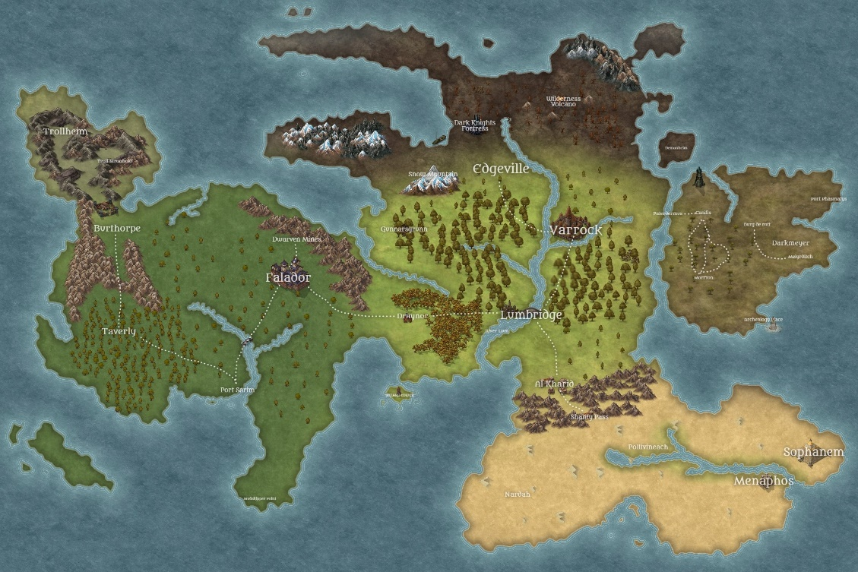

Figure 1. Reimagined World Map for Dungeons & Dragons (Source: https://www.reddit.com/r/2007scape/comments/k1hx4i/reimagined_world_map_for_my_dungeons_and_dragons/)

# Assignment

Create and describe the history of a fictitious world map (by hand or with a computer) that shows how plate tectonics has shaped the new world you imagined.

A. The map you create must include the following:

* At least 2 examples (each) of continental and oceanic plates
* At least one example of each of the three plate boundary types
* At least one continental and one oceanic rift zone
* At least one hot-spot
* At least one of each convergence zone
* Examples of at least one landform (volcano, folded mountain ranges, trenches, etc.) caused at each boundary
* It must show ages of crustal rock matching the plate movements and activity on the world’s surface

B. Describe, in detail, the map you have created. You may use any media (writing, verbal presentation, video, audio recording) to give the viewer a tour of the map describing the features listed above and how they relate to each other. For example, you might describe the mountains created by the continental to continental convergent boundary 400 million years ago indicated by the 300 to 400 million-year-old rocks at the peaks and the younger rocks present in the foothills at lower elevations and the island chain created near the center of the ocean where oceanic crust is being created at a hot spot.